1.create a directory ‘project_dir’ and cd to ‘project_dir’.

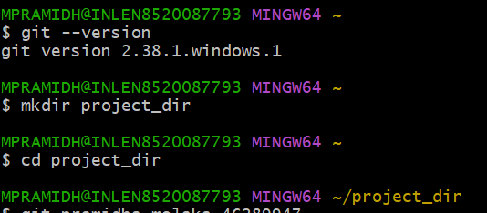

2.Intitialize git version database.

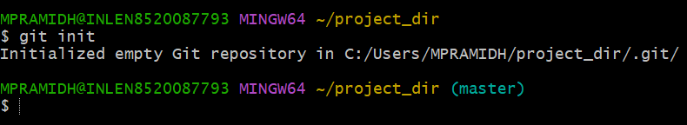

3. Create a new file index.html file.

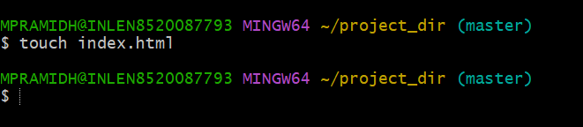

4. Check the git status. You should find index.html as untracked file.

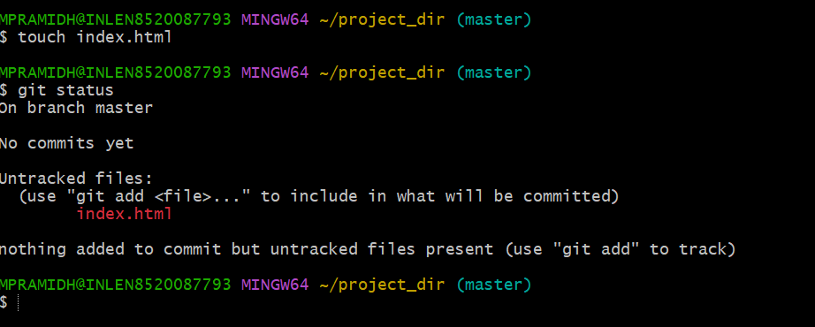

5.Stage the index.html file.

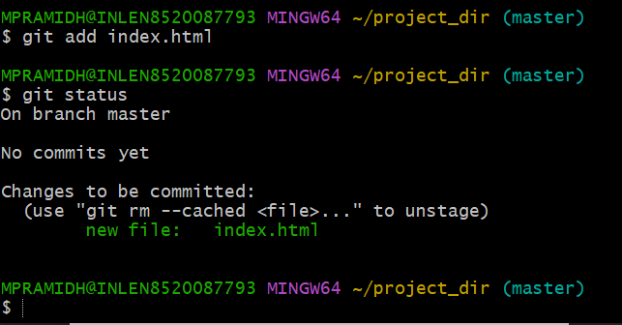

6.Commit index.html

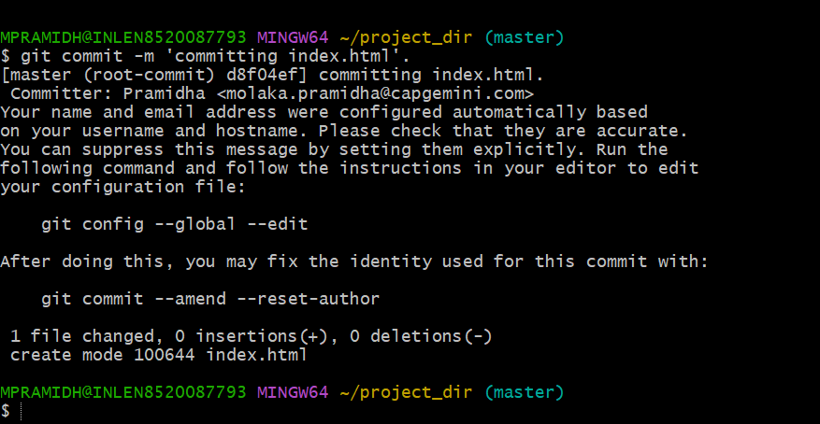

7.Make few changes in index.html & create a new file info.txt file.

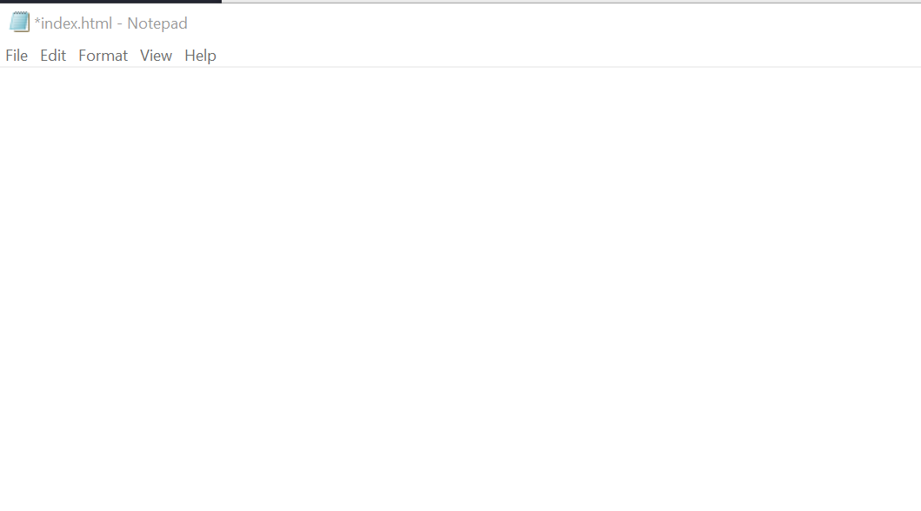

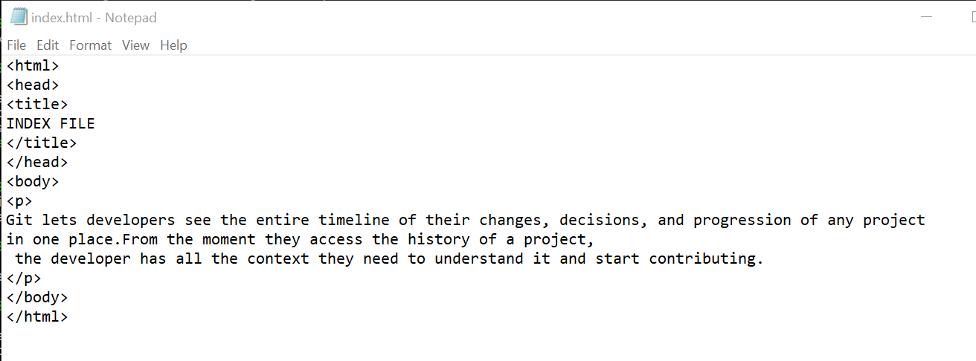

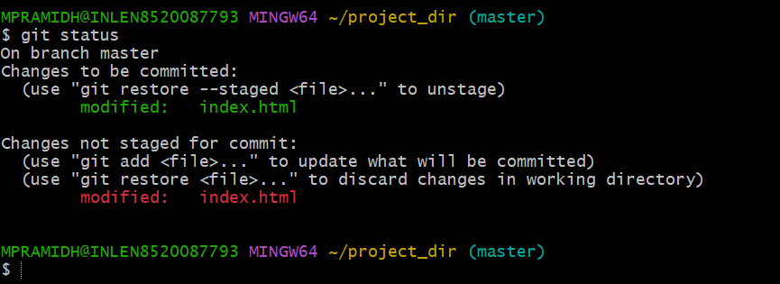

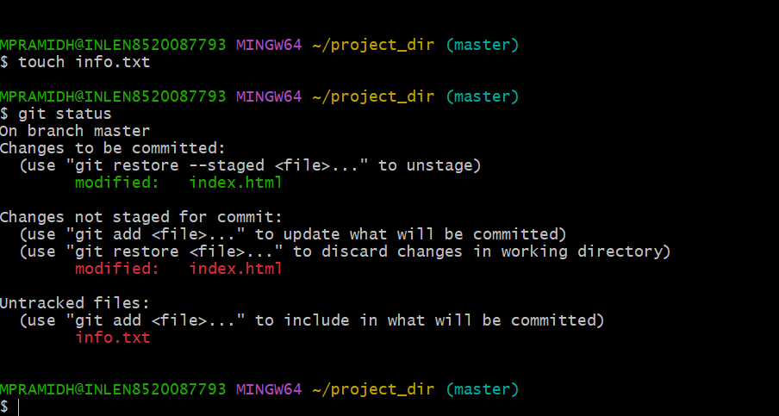

8. Check git status. You should find index.html & info.txt as untracked files.

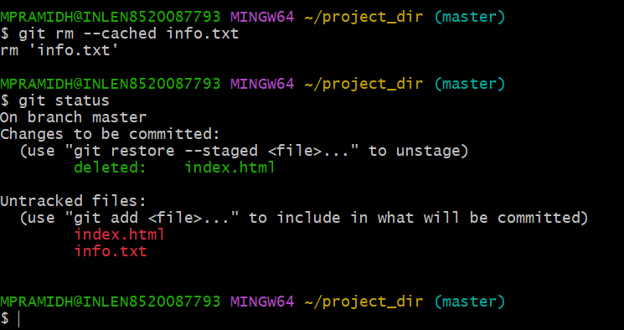

9.Configure GIT to ignore all txt files.

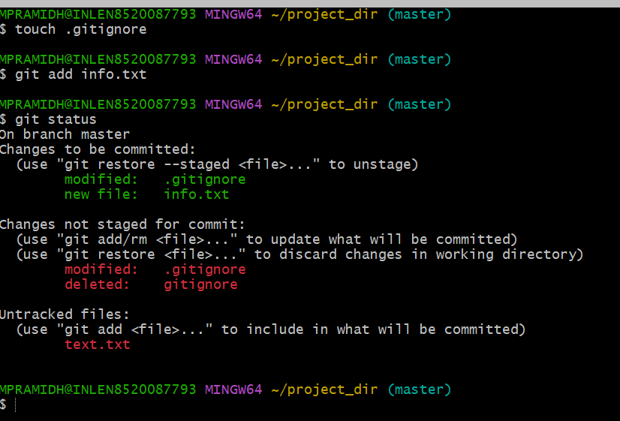

10.Again check the git status. You should find only index.html as untracked file.

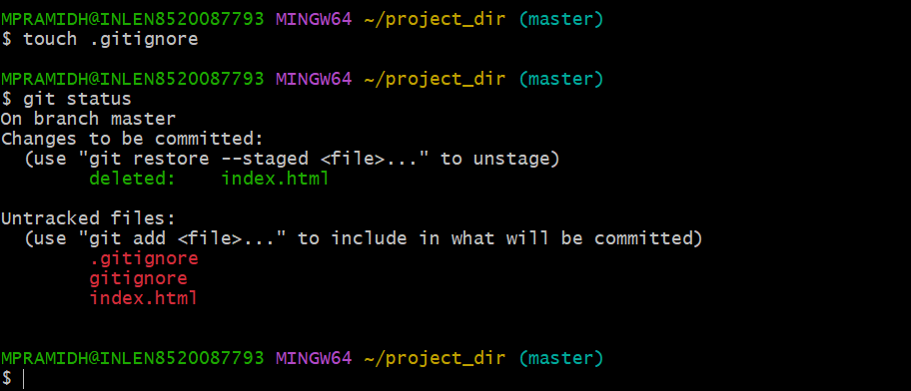

11.state and commit index.html

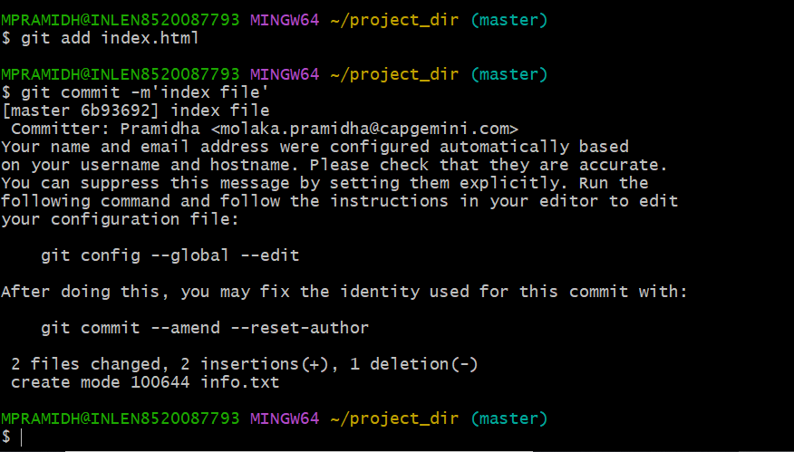

12.Log all your comments so far

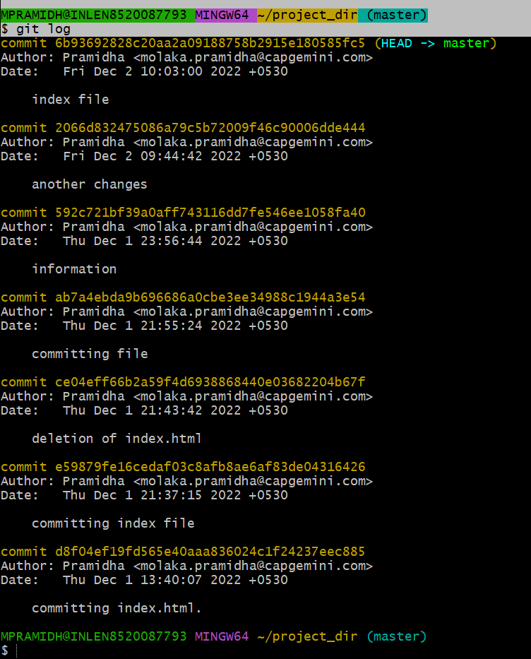

13.Make some changes in index.html

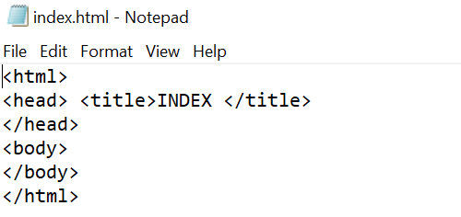

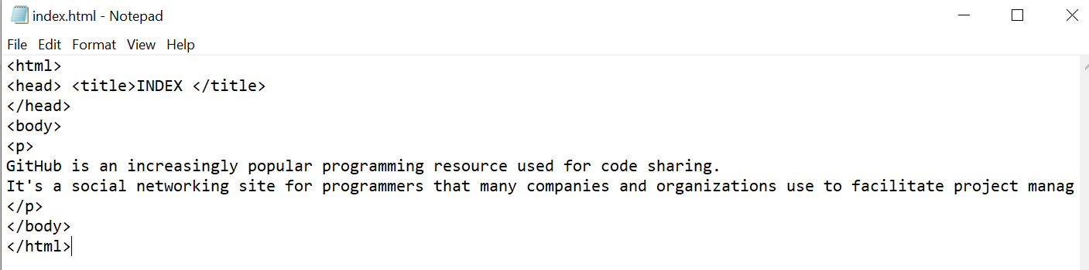

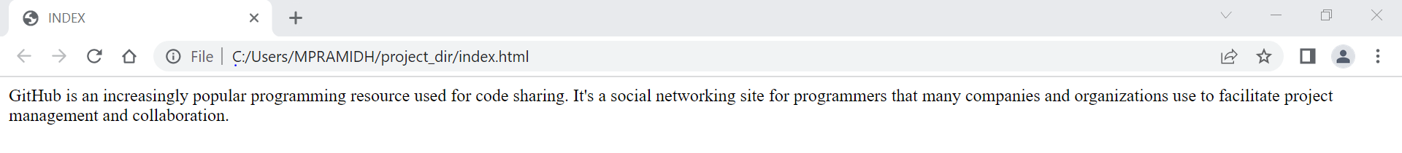

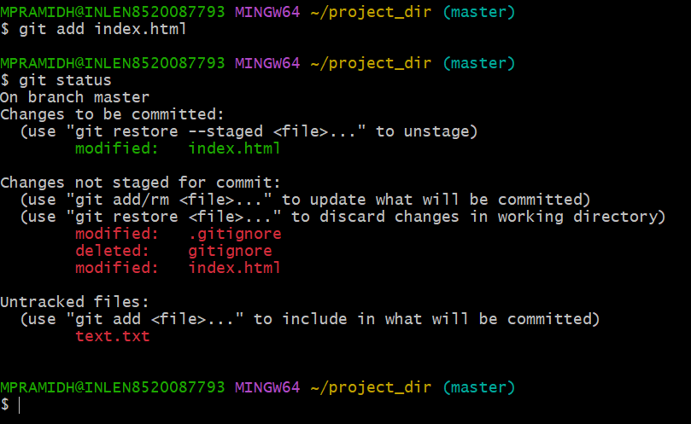

14.Revert the change made in the previous step using git command.

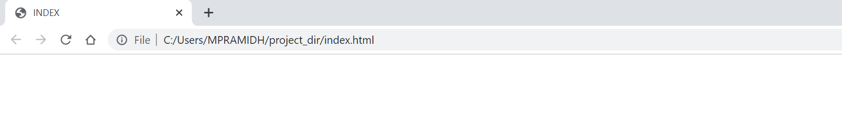

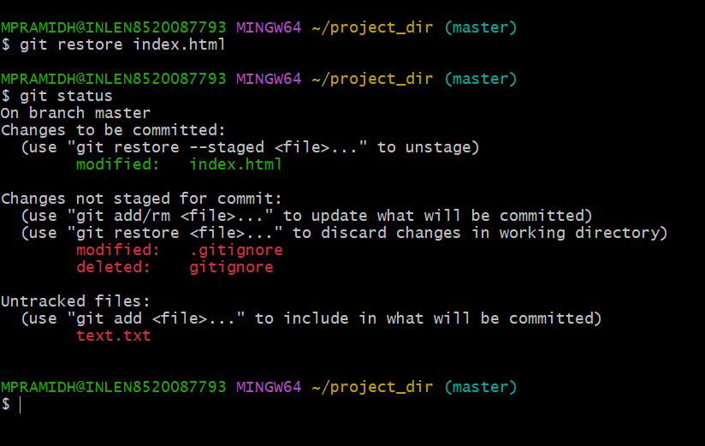

15.Again change index.html

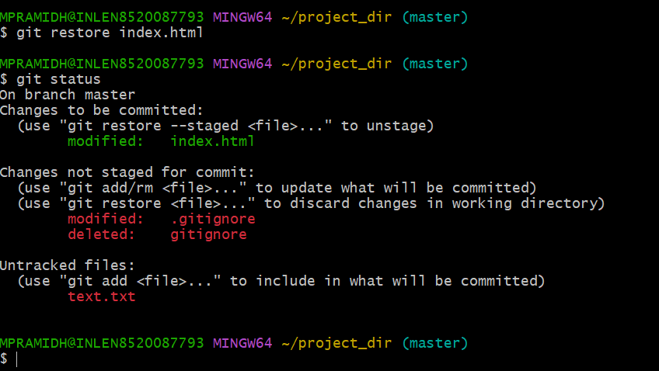



16.stage index.html

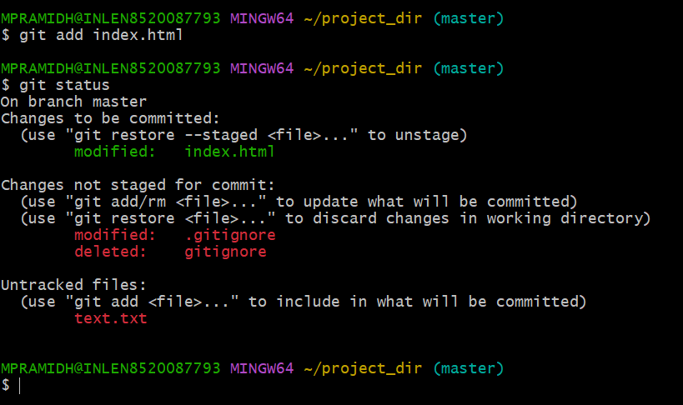

17.Revert add command to my-add

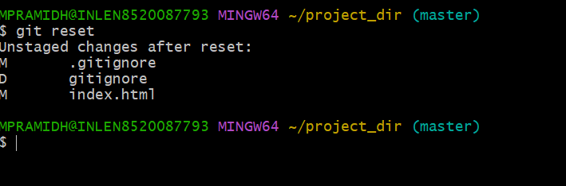

18. Rename add command to my-add

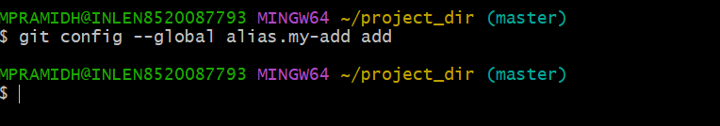

19.Using my add command stage index.html and commit the changes

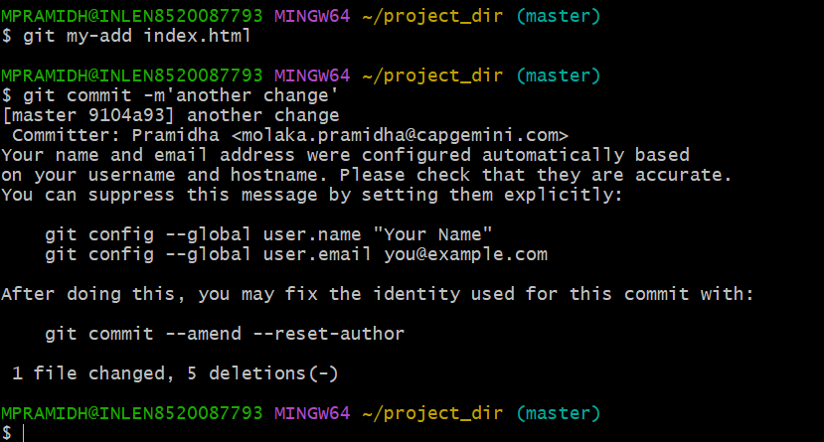

20.Revert the last commit

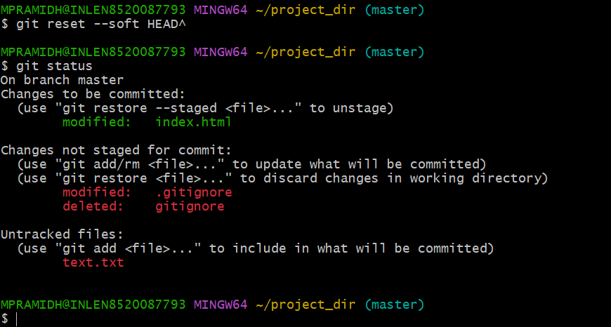

GIT – BRANCHING

22. Create an empty directory ‘Assignments’ & cd to ‘Assignments’.

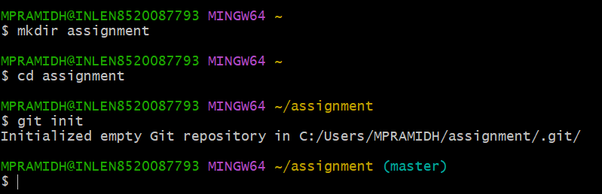

23. Create a file README.txt inside ‘Assignments’ & write few lines about the contents of ‘Assignments’ folder.

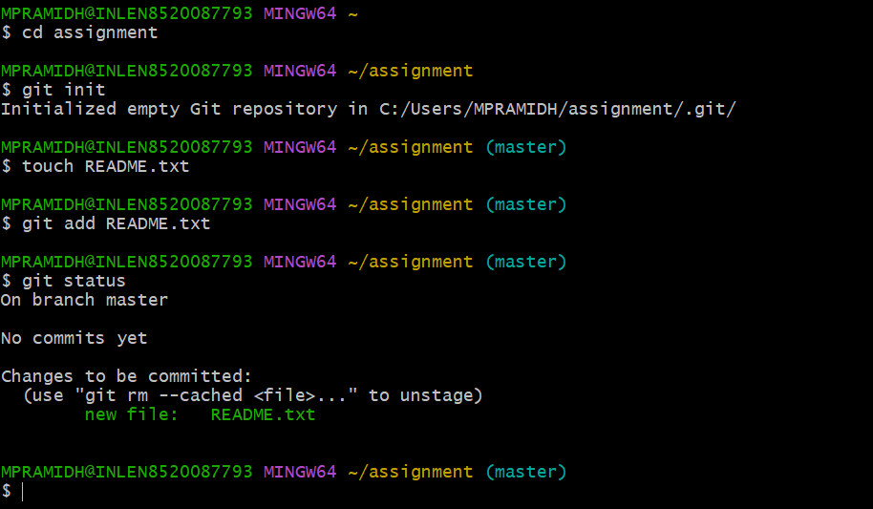

24. Commit README.txt file

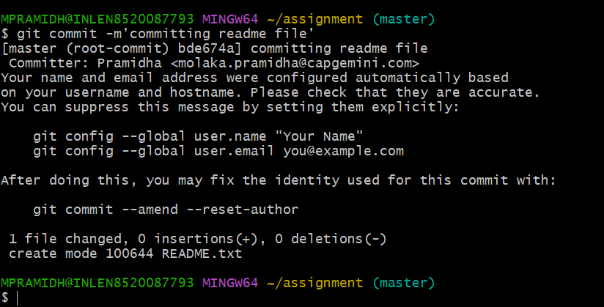

25.Now create a new branch ‘html –assignments.’

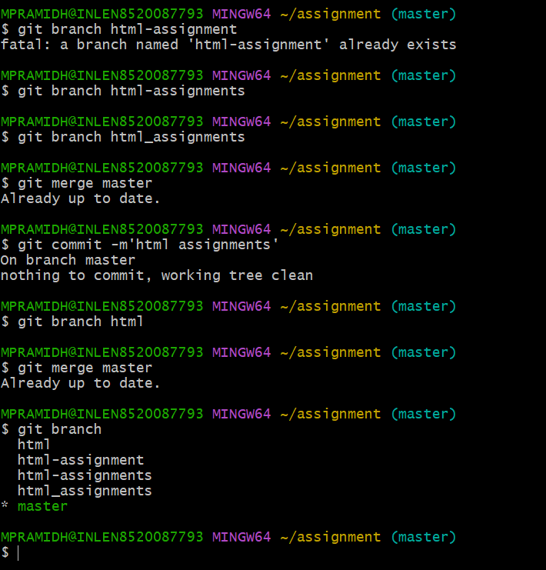

26. Switch to ‘html-assignments’ branch.

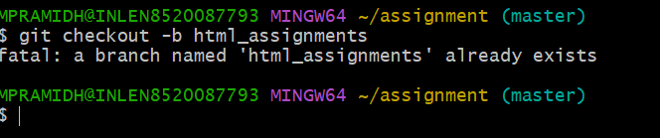

27. Copy all HTML assignments inside ‘Assignments’ folder.

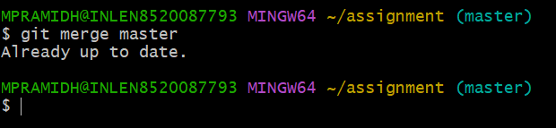

28. Commit HTML assignments into ‘html-assignments’ branch.

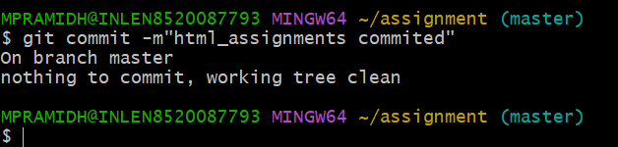

29. Make minor changes into few files belonging to ‘html-assignments’ branch

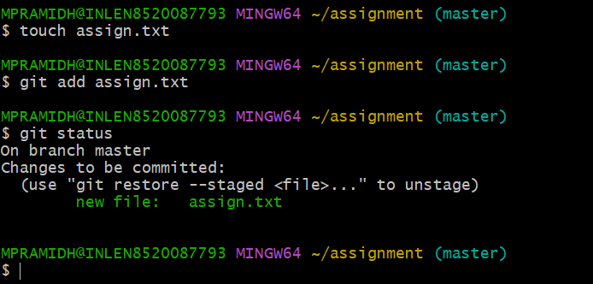

30.Commit those changed files.

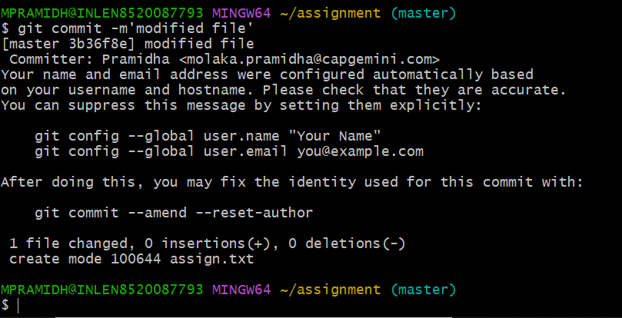

31. Switch to master branch.

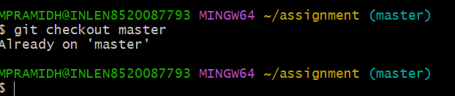

32. Make minor changes into README.txt file & commit those changes into master.

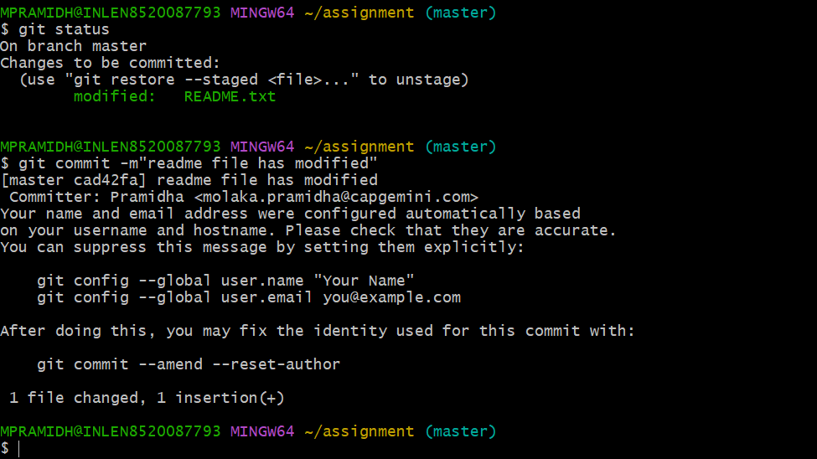

33. Again switch to ‘html-assignments’ branch.

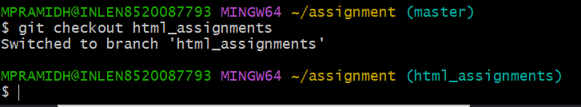

34. Make minor changes into few files belonging to ‘html-assignments’ branch.

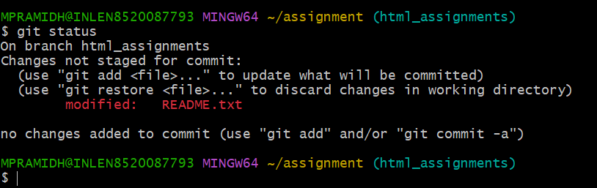

35.commit those changes.

